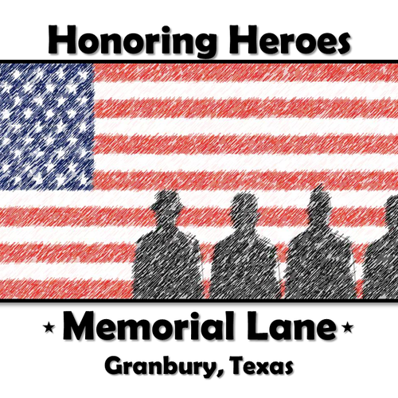

Mission Statement

The Jim Burks Firefighters Memorial Park has now expanded to include sites which honor all those who serve as fire fighters, law enforcement officers, first responders, and military personnel, from both past and present. “Memorial Lane” also contains sites for Places of Honor for those fallen heroes who have made the ultimate sacrifice. This is the reason for and purpose of Memorial Lane. You can help in this endeavor by purchasing a brick paver to honor those, wherever they have lived, who have served or who are currently serving.
Memorial Lane Engraved Pavers Order Form
- $60 PER PAVER –
ONE ORDER FORM PER PAVER PLEASE
Please mail this form along with your check or money order to:

Friends of Memorial Lane
PO Box 845
Granbury, TX 76048

Make your check payable to Friends of Memorial Lane

Please check site for this paver placement:

Fire Fighter Law Enforcement Military ______________________
(indicate which branch)
3 lines, 18 characters per line maximum (numbers, punctuation marks and spaces count as a character

PLEASE PRINT CLEARLY
Purchaser’s Name ______________________________________________________

Address ______________________________________________________________

City ______________________________________ State ______ Zip ____________

Phone _____________________ Email _____________________________________

Please make out check or money order to Friends of Memorial Lane.
Also, allow 6 weeks for check processing, paver engraving and then placement in the correct site. For questions or concerns call Bob @ 817-308-7426 or Connie @ 214-543-8433.

